CONCORDIA UNIVERSITY

DEPARTMENT OF COMPUTER SCIENCE AND SOFTWARE
ENGINEERING

SOEN 6441(FALL 2019)

INSTRUCTOR: KHALED JABABO

RISK GAME (BUILD-1)

ARCHITECTURAL DESIGN

BY:

Team - 13

SHUBHAM RANADIVE (40083991)

PARTH PATEL (40081116)

MEHUL PRAJAPATI (40076930)

KOMAL PANCHAL (40130791)

MARYAM GIAHI (40016260)

MAHMOUDREZA ENTEZAMI (40058782)

Index

1.Scope

- Architecture Design

3.Modules Description

3.1.Controllers

3.2.Entity

3.3.Maputilities

3.4.Configuration

3.5.Gameutilities

3.6.Main

3.7.Exception

3.8.Strategy

3.9.Model

4.Test Cases (Junit) Description

5.Tools and API

6.Refactoring

7.References
Introduction

Develop a RISK game using Model View Controller (MVC) software design architecture with iterative development to deliver working modules in small builds. It was an effort to use extreme programming key features such as Pair programming, Collective ownership, Coding Standards and many more.

1.Scope

The scope of the build 1 is as per the instruction guidelines for the build:

- Map Editor:

  - Create a new map file

  - Edit an existing map file

  - Add/Update/Delete Continent, Country and Adjacent Country

  - Make sure that the integrity of the connected graph is maintained.

- Game Play:

  - Assigning country to player

  - Player can assign armies to each country in round robin manner

  - With proper calculation of armies, Reinforcement phase is implemented

  - With a valid fortification move, Fortification phase is implemented
2.Architecture Design

Handles an Exceptions if occurs in any file
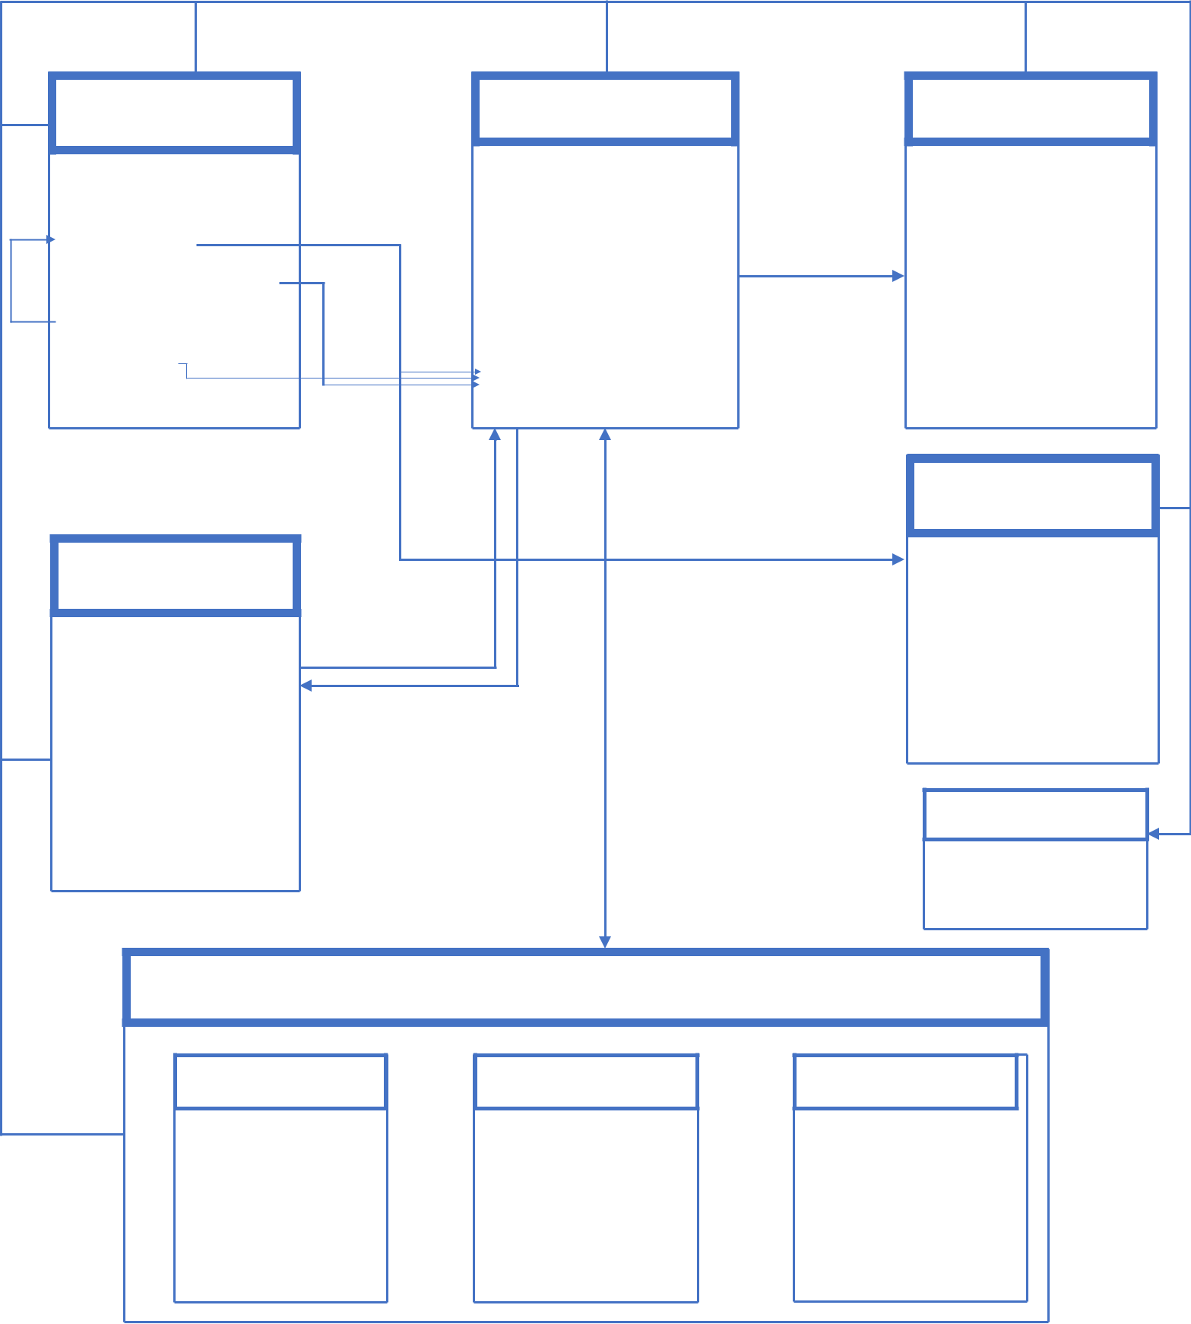

 | Model |  |  | Controller |  | View
 |  |  |  | CardExchangeController.java |  | Game Play
 | GameUIStateModel.java |  |  | DiceController.java |  | Game Play
 | GameUIStateModel.java |  |  | DiceController.java |  | Map Editor
 | PlayerModel.java |  |  | MainController.java |  | Map Editor
 | PlayerModel.java |  |  | MapRedactorController.java | Update the | Splash Screen
Notify | WorldDominationModel.java |  |  | MapRedactorController.java | views | Splash Screen
Notify | WorldDominationModel.java |  |  | MapRedactorSplashController |  | Splash Screen
Notify | WorldDominationModel.java |  |  | MapRedactorSplashController |  | Map Editor Splash
 | DiceModel.java |  |  | .java |  | Map Editor Splash
 | CardModel.java |  | Notify | PlayerStrategyChooser.java |  | Dice View
 | CardModel.java |  | Notify | PlayGameController.java |  | Dice View
 | TournamentModel.java | On |  | PlayGameController.java |  | Card View
 | TournamentModel.java | On |  | TournamentController.java |  | Card View
 | TournamentModel.java | Request |  | TournamentController.java |  | Card View
 |  |  |  |  |  | Strategy
 | Entity |  |  |  | Calls | Human.java
 |  |  |  |  |  | Cheater.java
 | Continent.java |  |  |  |  | Random.java
 | Continent.java | Returns values of attribute |  |  |  | IStrategy.java
 |  |  |  | functions |  | IStrategy.java
 | Country.java | Sets values of attribute |  | functions |  | Aggressive.java
 |  |  |  | functions |  | Benevolent.java
 | Map.java |  |  | common |  | Benevolent.java
 | Player.java |  |  | common
 | Player.java |  |  | set of |  | Exceptions
 | Card.java |  |  | Utilizes |  | InvalidGameAction.java
 |  |  |  |  |  | Invalidmap.java
 |  |  | Set of Common functions
 | Configuration |  |  | Map utilities | Game utilities
 | Configuration.java |  |  | CommonMapUtilities.
 |  |  |  | java
 | PlayerStrategy.java |  |  | MapOperations.java | GameUtilities.java
 |  |  |  | MapReader.java
 | CardKind.java |  |  | MapVerifier.java
 |  |  |  | MapWriter.java

3.Modules Description

3.1.Controllers

File_Name | Description
PlayGameController.java | It is a mediator between the GameUtilities class and
 | gameplay.fxml file. It captures all the user action like
 | creation of player, assigning armies, all the three phases
 | of the risk game etc.
MapRedactorController.java | It is a mediator between the MapOperations and the
 | mapeditor.fxml. It captures all the user actions like add,
 | update and delete continent or country or adjacent
 | countries.
MapRedactorSplashController.java | It controls the user action from mapeditorsplash.fxml
 | and calls new controller to open a pane of javafx.
MainController.java | This file handles the user action from main screen.
PlayerStrategyChooserController.java | It allows to choose a player Strategies for selected
 | number of player (i.e Human or Computer)
CardExchangeController.java | This class is the controller for the card exchange view.
DiceExchangeController.java | This class is the controller for the dice view.
TournamentController.java | This class is the controller for the tournament mode.
3.2.Entity
File Name | Description
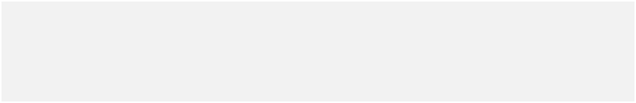
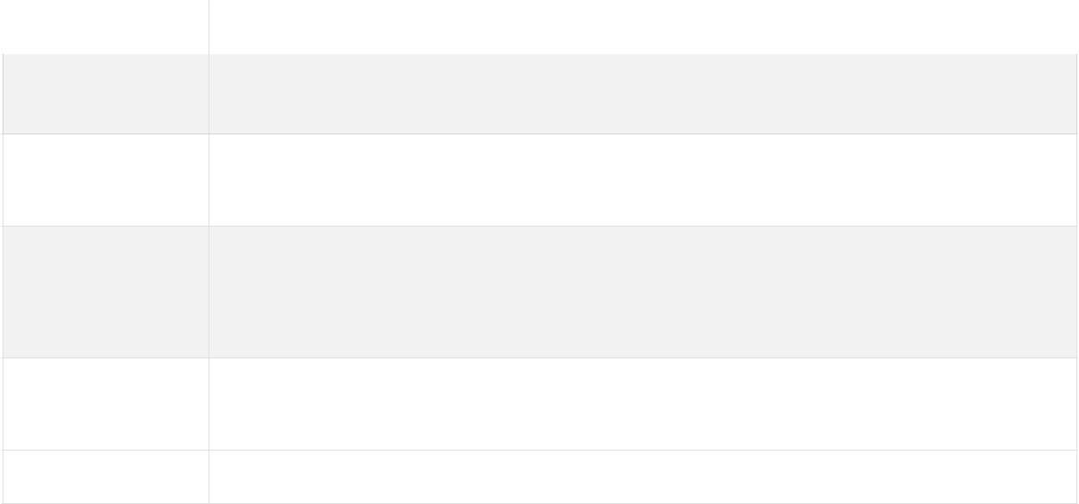

Map.java It contains all the information of the Map and a list of the continents.

Continent.java It contains all the information of the continent and a list of all the countries that belong to a continent.

Country.java It contains the information of the country like name, a reference to which continent the country belongs, list of all the adjacent country, count of armies currently residing on the country.

Player.java It contains all information related to a player and the number of armies assigned to the player.

Card.java It contains all the information regarding to Card.
3.3.Maputilities

File Name | Description
MapReader.java | It reads the map file format and parsing in to Map object and also
 | checks for the validity of the data of the map file.
MapWriter.java | It is responsible for writing the Map object to the file.
CommonMapUtilities.java | Contains all the common method of the map like: saving map
 | object, opening a dialogue box etc.
MapOperations.java | It perform operation like addition or update or deletation of country
 | or continent.
MapVerifier.java | This class validates the map.

3.4 Configuration

File Name | Description
Configuration.java | It defines global constant variables and messages for the application
CardKind.java | Enumeration for defining 3 card types for the game.
PlayerStrategy.java | Enumeration for defining player strategies ( Human ).

3.5 Gameutilities

File Name | Description
Gameutilities.java | It handles the common operations for the game play phase.

3.6.Main

File_Name | Description
Main.java | Entry point for the application
3.7.Exception

File_Name |  | Description
InvalidMap.java |  | It manages exception of the map validation.
InvalidGameAction.java |  | It manages exception of the Gameplay phase.
3.8.Strategy
File_Name |  | Description
Human.java |  | It implements Human Strategy when player want to play
 |  | manually.
IStrategy.java |  | This interface defines methods which are to be implemented
 |  | by the strategies.
Aggressive.java |  | It implements Aggressive Strategy of the Player.
Benevolent.java |  | It implements Benevolent Strategy of the Player.
Cheater.java |  | It implements Cheater Strategy of the Player.
Random.java |  | It implements Random Strategy of the Player.
3.9 Model
File_Name |  | Description
PlayerModel.java | It handles operations of the players such as reinforce,
 | fortification and many others.
WorldDominationModel.java | It provides the data for the chart to the PlayGameController.
GameUIStateModel.java | It stores the state of the button.
CardModel.java | This class handles the operation regarding card. This clsss
 | notifies the PlayGameController if it is changed.
DiceModel.java | This class also notifies the PlayerModel if it is changed and
 | handles the operation related to dice like rolling dice and
 | comparing dice.
TournamentModel.java | This class implements methods for the tournament which are
 | called from the TournamentController.java.
4.Test Cases (Junit) Description

 | Main
File_Name | Description
MainTestSuite.java | This is a test class for running all test suits.
 | ( MapUtilitiesTestSuite.class, GameUtilitiesTestSuite.class,
 | ModelsTestSuite.class, StrategyTestSuite.class)
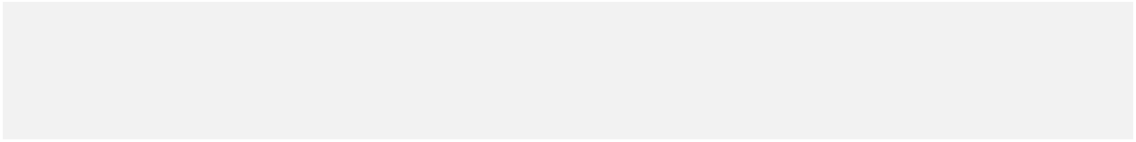

 | Gameutilities
File_Name | Description
GameUtilitiesTest.java | This is a test class for GameUtilities.
 | i.e. one of its method tests the allocation of country to
GameUtilitiesTestSuite.java | i.e. one of its method tests the allocation of country to
GameUtilitiesTestSuite.java | player is working or not.
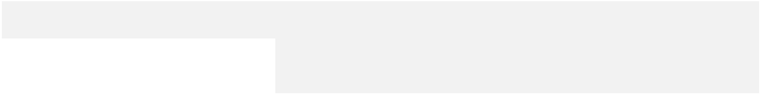

 | Maputilities
File_Name | Description
MapOperationsTest.java | This is a test class for Map operations.
 | i.e. one of its method tests the functionality to map a
 | Country with the continent.
MapReaderTest.java | This is a test class for Map Reader.
 | i.e. one of its method tests the map which has countries
 | without continents.
MapVerifierTest.java | This is a test class for Map varifier.
 | i.e. one of its method tests if the program can load
 | unconnected continent map.
MapUtilitiesTestSuite.java | This is a test class for running all test suits in Maputilities
 | i.e. (MapReaderTest.class, MapOperationsTest.class,
 | MapVerifierTest.class)

 | Controller
File_Name | Description
ControllerTestSuite.java | This is a test class for the controller files.
MainControllerTest.java
PlayGameControllerTest.java
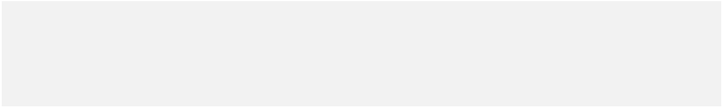
 | Strategy
File_Name | Description
RandomTest.java | This is a test class for the strategies Random, Aggresive,
 | benevolent and cheater.
AggressiveTest.java | benevolent and cheater.
AggressiveTest.java | i.e. one of its method tests the normal functionality of the
BenevolentTest.java | i.e. one of its method tests the normal functionality of the
BenevolentTest.java | getRandomCountry method.
CheaterTest.java
StrategyTestSuite.java
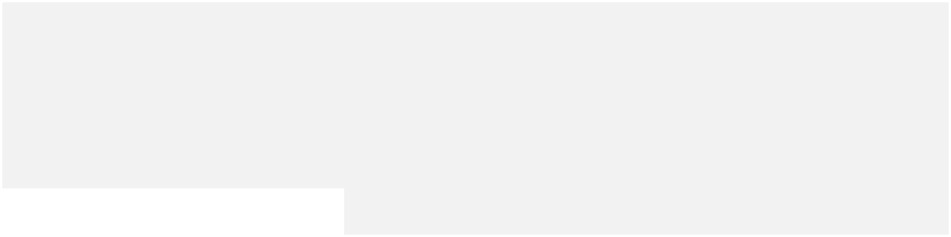

 | Models
File_Name | Description
PlayerModelTest.java | This is a test class for Player, Dice, Card and tournament
 | Model.
DiceModelTest | Model.
DiceModelTest | i.e. one of its method tests the number of armies for
CardModelTest | i.e. one of its method tests the number of armies for
CardModelTest | different players in player model.
TournamentModelTest
ModelsTestSuite.java
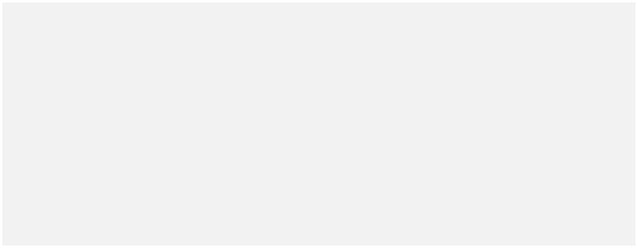

5.Tools and API

Tools | Description
Eclipse | IDE for the game development
Scene Builder | It is an open source JavaFX system used for UI design and gives a skeleton
 | of the events to be implemented in controller.
JavaFx | Library to control the UI component
Source Tree | It is Git code management System which gives one place to plan projects,
 | collaborate on code, test and deploy.
Junit 4 | Junit 4 for writing test cases
Maven | Maven as a build automation tool to manage all project dependencies.
6.Refactoring

No. | File | Description
1 | PlayerModel.java | Applied substitute algorithm in which we have replaced
 |  | logic of method[2]
 |  | { we’ve used array of number_of_armies instead of switch
 |  | case for assigning armies to the players. }
2 | Human.java | Applied Extract method in which we’ve moved some part of
 |  | the code to separate new method and replace that code with a
 |  | call to the method.[2]
 |  | { We’ve created new method for alertBox as it is used many
 |  | times in a file by calling that method with parameters. }
3 | PlayerModel.java | Removed textAreaMsg from the parameter of the
 | PlayGameController.java | tradeCardsAndGetArmy(…) method in player model -
 |  | redundant parameter passing removed
4 | Playermodel.java | The name of a method does not reveal its purpose so,
 | MapRedactorController | refactored it by changing it.
 | .java | { onClickContList -> onClickContinentList ;
 |  | onClickCounList -> onClickCountryList ;
 |  | assignarmiestocountry -> assignArmiesToCountry }
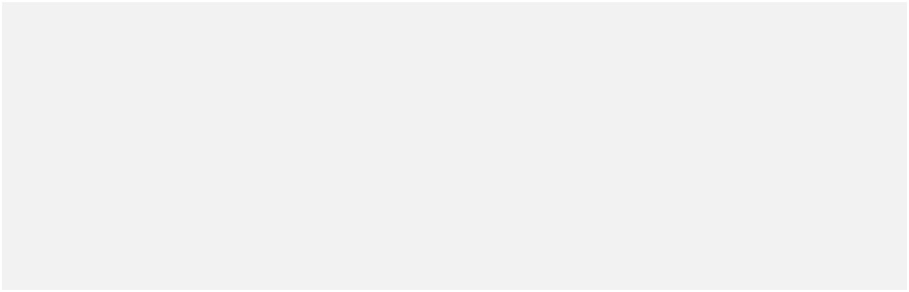

7. References :

- Rules Followed : https://www.wikihow.com/Play-Risk

- https://sourcemaking.com/refactoring/refactorings

- https://www.sourcetreeapp.com

